Case 3-A283-Asia-Indus-Bowl-Fish-[Pristipomoides zonatus](http://www.fishbase.org/summary/SpeciesSummary.php?id=211)-Terracotta-1900 BCE

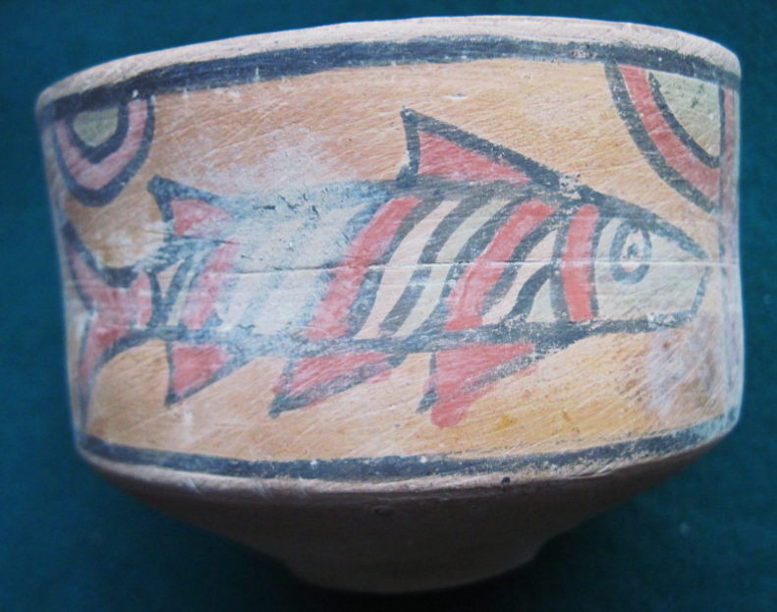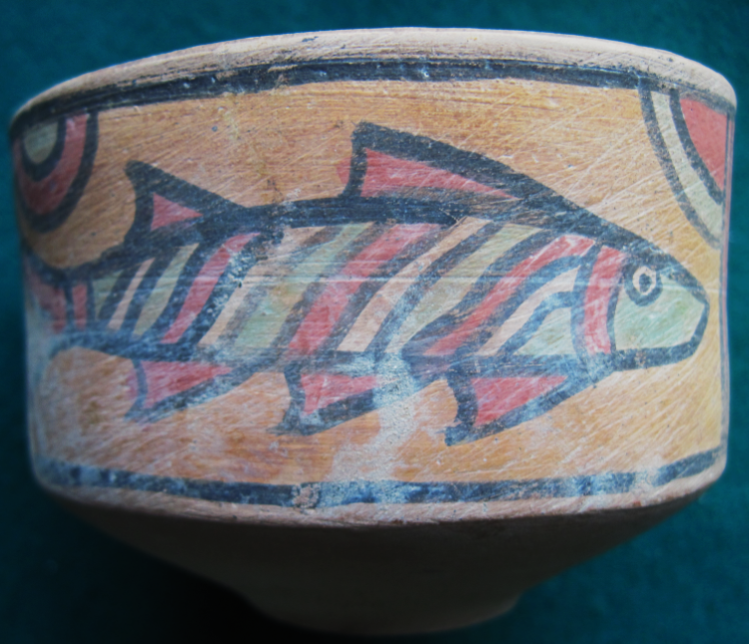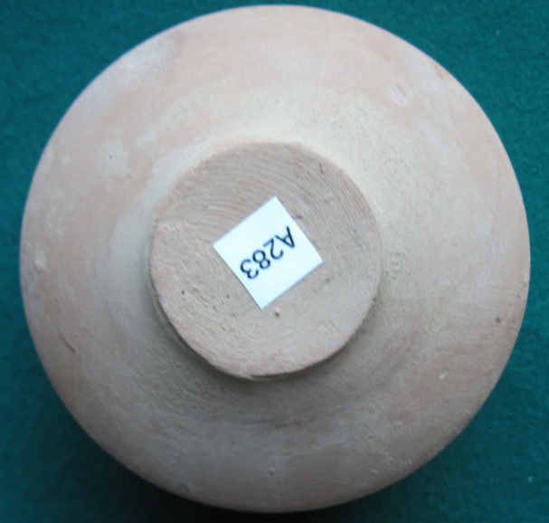

Figs. 1-3.

**Case no.: 3**

**Accession Number: A283**

**Formal Label:** A283-Asia-Indus-Bowl-Fish-[*Pristipomoides zonatus*](http://www.fishbase.org/summary/SpeciesSummary.php?id=211)-Terracotta-1900 BCE

**Display Description:**

This bowl has two depictions of a red-yellow-green diagonally striped snapper the only species from Indian waters that has a similar coloration is[*Pristipomoides zonatus*](http://www.fishbase.org/summary/SpeciesSummary.php?id=211)*,* which is also a prized eating fish as well as being colorful.

The fish Matsya (मत्स्य) in Hindu mythology is the first of ten Avatars of Vishnu, who is described in the *Matsya Purana* as the deity that saves Manu, the first human.

The *Matsya Purana* was probably first collected in the third century AD/CE but sections may date to the first millennium BCE (or earlier as oral literature) before they were collected. “Puranas are a stratified literature. Each titled work consists of material that has grown by numerous accretions in successive historical eras. Thus no Purana has a single date of composition. (...) It is as if they were libraries to which new volumes have been continuously added, not necessarily at the end of the shelf, but randomly” (Dimmitt and van Buitenen 2012: 5).

Given the proposed dating of this bowl to ca 1900 BCE with images of [*Pristipomoides zonatus*](http://www.fishbase.org/summary/SpeciesSummary.php?id=211)as the representative of Matsya’s fish, we suggest that oral portions of the myth situate it on the same time horizon as the Noah flood myth in the Hebrew *Bible* and the [Gilgamesh flood myth](https://en.wikipedia.org/wiki/Gilgamesh_flood_myth) in Mesopotamia.

**LC Classification:**

**Date or Time Horizon:** 1900 BCE

**Geographical Area:** Coastal India. 35°N - 29°S to 34°E - 146°W

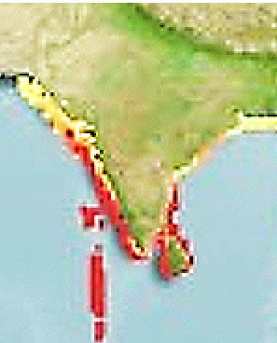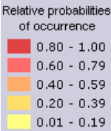

Fig. 4. Specimens of Gindai, *Pristipomoides zonatus*, showing growth and development over different life stages as they were indicated in the *Matsya Purana*. From NOAA. 2009. Scientific Studies Designed to Learn More about Juvenile Bottomfish and Larval Billfish in Hawaiian Waters, <https://www.pifsc.noaa.gov/cruise/oes0903.php>. [Pristipomoides zonatus](http://www.fishbase.org/summary/SpeciesSummary.php?id=211) is a marine, benthopelagic, oblique, banded snapper with a depth range of 70 - 300 m occurring from 35°N - 29°S to 34°E - 146°W with a maximum size of 50 cm. They feed on fishes, shrimps, crabs, cephalopods, miscellaneous benthic invertebrates and pelagic organisms, including urochordates. It has a commercial and gamefish economic value (Allen 1985).

Fig. 5. Map of occurrence of [Pristipomoides zonatus](http://www.fishbase.org/summary/SpeciesSummary.php?id=211) on the Indian sub-continent. From [http://www.aquamaps.org/receive.php?type_of_map=regular: (Kaschner](http://www.aquamaps.org/receive.php?type_of_map=regular:%20(Kaschner) et al. 2016).

**Geographical Area:** Harappa

**Map, GPS coordinates:**

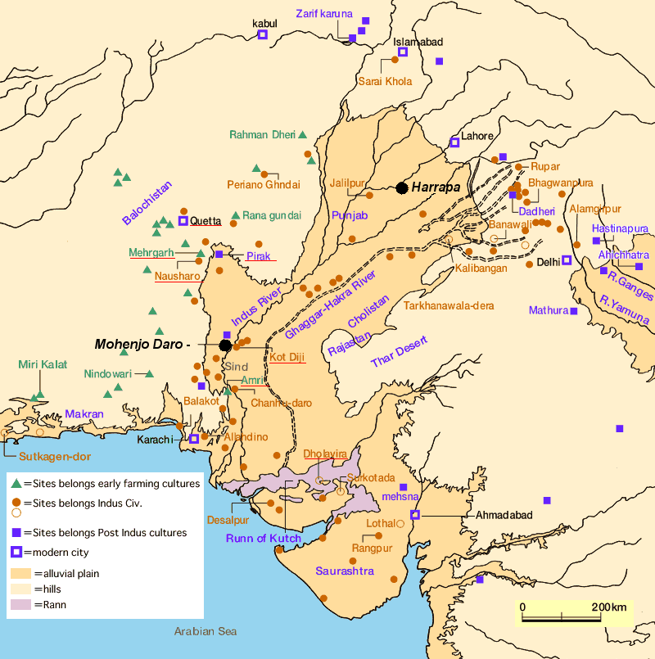

Fig. 13. Map of Indus sites from https://encrypted-tbn0.gstatic.com/images?q=tbn:ANd9GcSnoolUCyM4saSet1fqKCqzYEWJhfDBzJsATILKpXYgG8P2maLY.

**Map, GPS coordinates:** [27°19′45″N 68°08′20″E](https://tools.wmflabs.org/geohack/geohack.php?pagename=Mohenjo-daro&params=27_19_45_N_68_08_20_E_type:landmark)

**Cultural Affiliation:** Harappa

**Media:** Terracotta, black, yellow, red and green pigment.

**Dimensions:**

**Weight:**

**Condition: original**

**Provenance:** UK Collection

**Discussion:**

The [Matsya Purana](http://en.wikipedia.org/wiki/Matsya_Purana) in its third century AD/CE version presents the following story of the righteous man, Manu, who was saved by Matsya (from http://www.bharatadesam.com/spiritual/matsya_purana.php):

**Vishnu and Manu**  
  
There used to be a king named Manu. He was the [seventh] son of the sun-god [Vivasvana]. When it was time for Manu to retire to the forest, he handed the kingdom over to his son [Ikshvaku]. Manu then went to the foothills of Mount Malaya and started to perform tapasya [meditation]. Thousands and thousands of years passed. Such were the powers of Manu’s meditation that Brahma appeared before him. "I am pleased with your prayers," said Brahma. "Ask for a reward." "I have only one reward to ask for," replied Manu. "Sooner or later there will be a destruction [*pralaya*], and the world will no longer exist. Please grant me the reward that it will be I who will save the world … at the time of the destruction." Brahma readily granted this reward. Days passed.

One day Manu was performing ablutions in a pond near his hermitage. He immersed his hands in the water so that he might offer some water to his ancestors. When he raised his cupped hands, he found that there was a minnow [*shafari*] swimming around in the water. Manu had no desire to kill the minnow. He placed it carefully in his water-pot [*kamandalu*].  But the minnow started to grow and within a day, it was sixteen fingers in length. "Save me, king." said the fish. "This water-pot is too small for me."  
 Manu then placed the fish in a vat. But the fish continued to grow and, within a day, it was three hands in length. "Save me, king." said the fish. "This vat is too small for me." Manu put the fish in a well, but the well soon became too small for the fish. Manu transferred the fish to a pond, but the pond was also too small for the fish. Manu now removed the fish to the holy river Ganga, but even this was too small for the fish.

Finally, Manu transferred the fish to the ocean. There the fish grew so much that it soon occupied the entire ocean. "Who are you?" asked Manu. "I have never seen or heard of such wonders. Are you a demon that is deluding me with its illusions? No, I do not think that you are a demon. You must be the great Vishnu himself. Please tell me the truth and satisfy my curiosity."  
  
Vishnu then revealed that it was indeed he who had adopted the form of a fish. He told Manu that the earth would soon be flooded with water. Vishnu had got a boat built by the gods. [In other accounts, Manu was himself asked to construct the boat]. When the earth was flooded, Manu was to place all living beings in the boat and thus save them. Vishnu would himself arrive in his form of the fish and Manu was to tie the boat to the fish’s horn. Thus the living beings would be saved. And when the waters of the flood receded, Manu could populate the world afresh and rule over it. [This is the more customary account. But in the Mahabharata, it was Brahma who appeared before Manu in the form of a fish.]

Vishnu disappeared, and for a hundred years there was a terrible drought on earth. The drought led to famine and people died of starvation. Meanwhile, the sun blazed in fury and burnt up the entire world. When everything had burnt to ashes, dark clouds loomed in the sky.

These are the clouds that appear at the time of destruction and there are seven classes of clouds, known *as samvarta, bhimananda, drona, chanda, valahaka, vidyutapataka* and *kona*. From the clouds, rain began to pour and soon, water engulfed the entire earth. The land mass was flooded. As instructed by Vishnu, Manu gathered together [all the righteous] living beings inside the boat.

**References:**

Allen, G.R., 1985. FAO Species Catalogue. Vol. 6. *Snappers of the world. An annotated and illustrated catalogue of lutjanid species known to date.* FAO Fish. Synop. 125(6):208 p. Rome: FAO.

|  |
| --- |
| Dimmitt, Cornelia and van Buitenen, J. A. B., eds. 1978. *Classical Hindu Mythology: A Reader in the Sanskrit Puranas.* Philadelphia: Temple University Press. |

Gietz, K. P. et al. 1992. Epic and Puranic Bibliography (Up to 1985) Annotated and with Indexes: Part I: A - R, Part II: S - Z, Indexes. Wiesbaden: Otto Harrassowitz Verlag.

Kaschner, K., K. Kesner-Reyes, C. Garilao, J. Rius-Barile, T. Rees, and R. Froese. 2016. *AquaMaps: Predicted range maps for aquatic species*. www.aquamaps.org, Version 08/2016.

[Rocher, Ludo](https://en.wikipedia.org/wiki/Ludo_Rocher). 1986. *The Puranas*. Wiesbaden: Otto Harrassowitz Verlag.

Vasu, Sudhīndra Nātha. 1916. *The Matsya Puranam*, Part 1 of 3 (Chapters 1-128). Allahabad: Panini Office.

Vasu, Sudhīndra Nātha. 1917. *The Matsya Puranam*, Part 2 of 3 (Chapters 129-199). Allahabad: Panini Office.